Created table “olympic” with “olympic_data.csv”

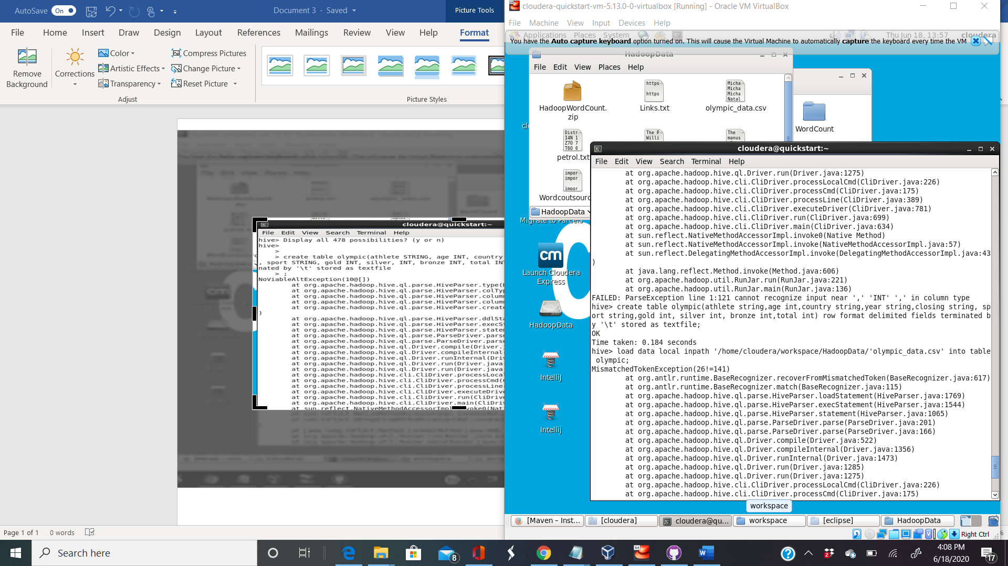

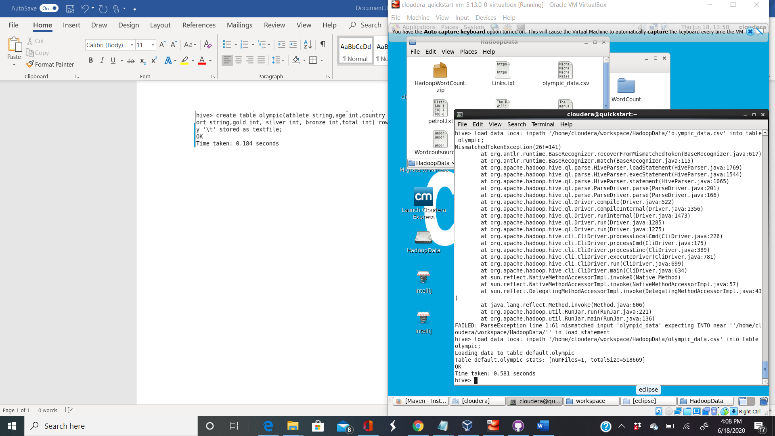

1. Shows swimming medals won for every country

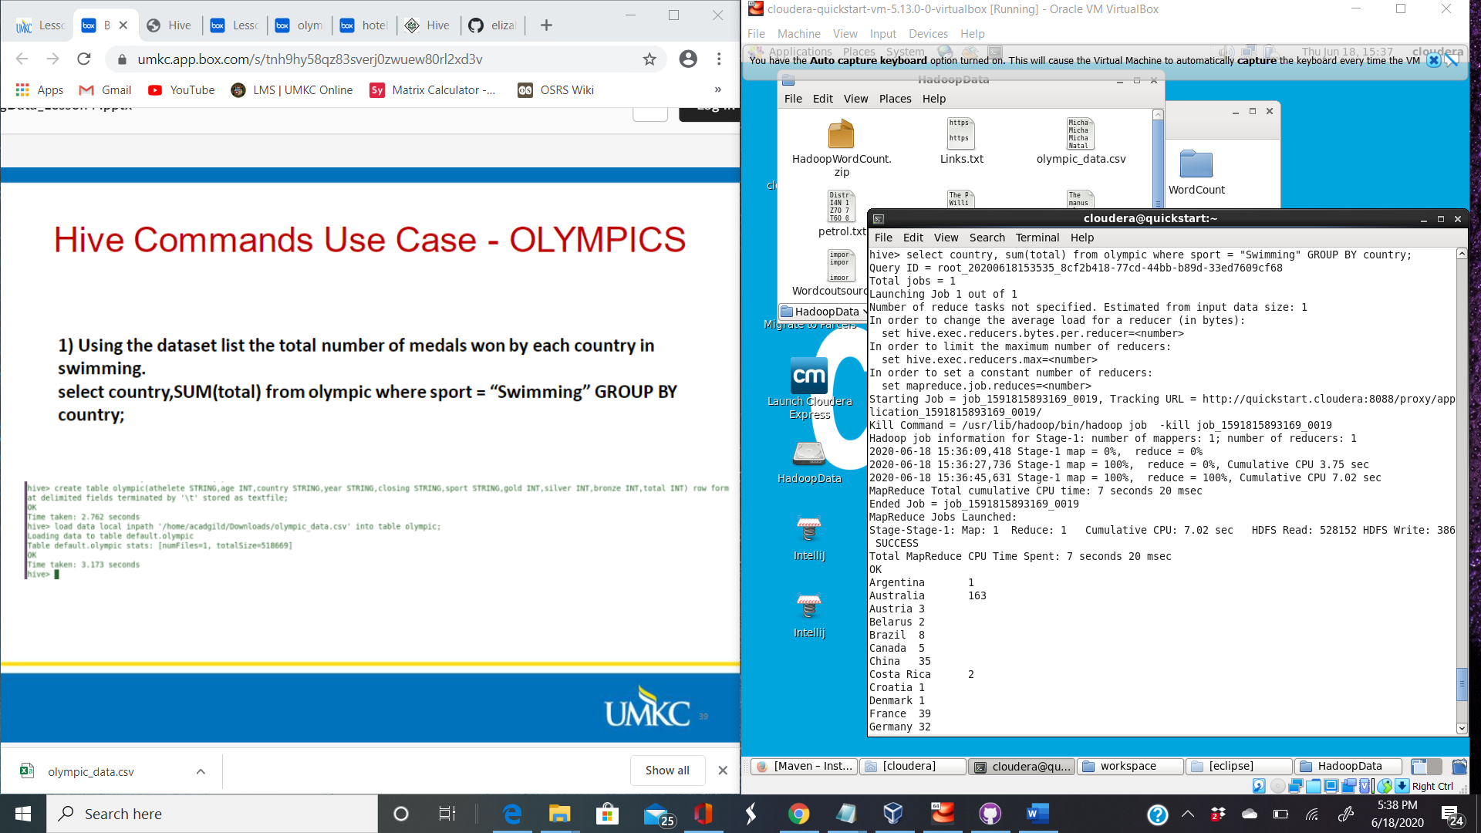

1. Shows number of medels India won for each year they won a medal.

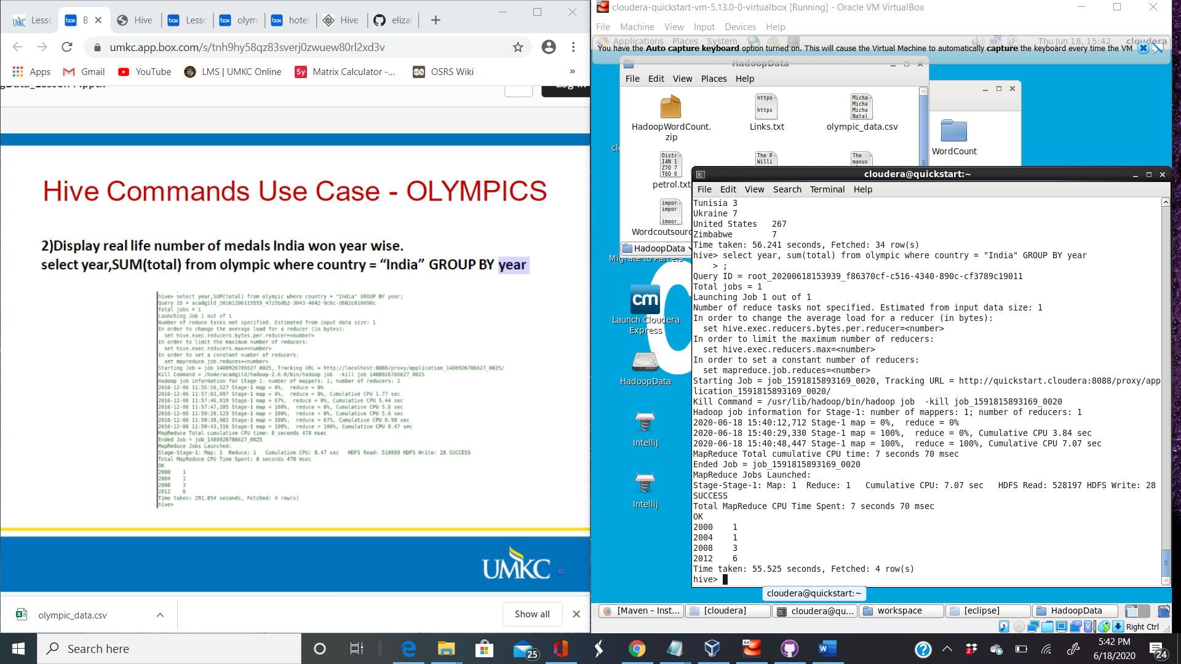

Shows number of medals won in total by each country

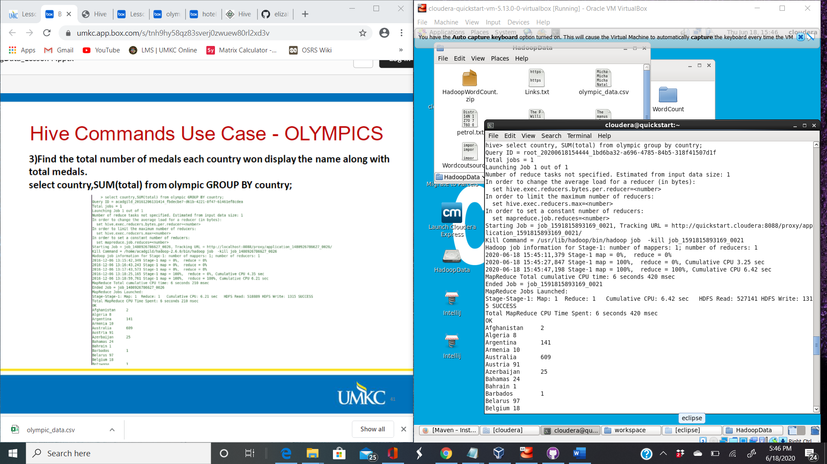

1. wShows number of only gold medals won by each country

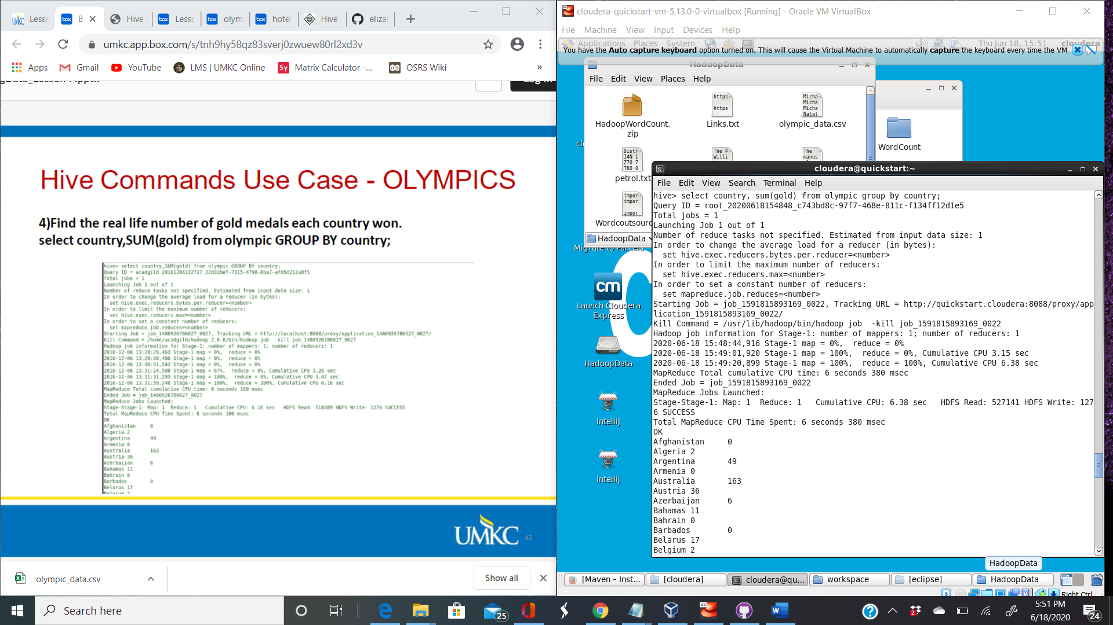

1. Shows countries that won a metals for shooting and in what year.

